4th grade Fossils
Objective: Students create their own “fossil bed” by modeling three-dimensional shapes of animals, plants or insects, then “burying” them beneath layers of tissue paper. Add earth-tone pastels to make them look as if they just came from an excavation site.
Students relate skills that are learned in art to what scientists do when they are investigating our past.
Standards:
Standard 1: Observe and learn to Comprehend
Standard 2: Envision and Critique to Reflect
Standard 3: Invent and discover to Create: Understanding and applying media, techniques and processes Students intentionally take advantage of the qualities and characteristics of art media, techniques and processes to enhance communication of their experiences and ideas.
Standard 4: Relate and Connect to Transfer: Making connections between visual arts and other disciplines Students identify connections between the visual arts and other disciplines in the curriculum. Students compare characteristics of visual arts within a particular historical period or style with ideas, issues or themes in the humanities or sciences.
Vocabulary:
Elements and Principles of Design
Fossils
Artifacts
Archeologist
Paleontologist
Accommodations for all learners: visuals, IPAD short movie clips that demonstrate the learning or provide information for the station that they are working at. Writing prompts and examples on how to start it at the tables that have to write. Instructions with pictures to help understand the process at the stations

Materials
- Fossil making station
Cut drawing paper into 4" x 4" squares. . Cut tissue into 6" x 6" squares. Cut armature wire into 15" long pieces. Thin the glue with a small amount of water and pour it into containers., Video about how to put it together on the IPAD
- Archeological dig station
Tub, dirt, string, tape, tools to dig, graph paper, pencils, ruler, IPAD with video about digging, broken pottery
- Piecing together an artifact station
Paper, elements and principal of design examples, pencil, broken pottery with images, painted to be able to piece together
- Types of Fossils station
Paper, types of fossils and information, directions, modeling clay, plastic toys, pencils,
- Archeological hypothesis
Worksheet that students have to create a hypothesis about the person based on what was found in the trash Dinosaur worksheets; pick 3 out of the five to do a write up on. Directions, pencils, and then when done they can use the IPAD to play the game that has them make connections to different bones, have directions

- Artist critique on Bob Slaughter’s mermaid sculpture, writing prompt, pencils, directions, image of the mermaid and plaque information (use the graphic organizer that was suggested this past Wednesday
- Curiosity box
Making observations about an unknown object, formulate a hypothesis to predict what the object might be, make a sketch of the unknown object, discuss as a table group challenges they encountered while completing the activity and note these challenges on the back of the hypothesis worksheet
Process:
- Students will come in and sit in the meeting area. Students will be introduced to the stations for the day. In class the students have begun their fossil unit. I will have students tell me what they have been learning about in class at this time
- We are going to be continuing your learning about fossil here in art class as well. So I want you to wear two hats today as we do stations. One as the archeologist as you dig, categorize, and hypotheses your thoughts at each station. And the other as an artist and what kinds of skills we use in art class also are used in Science. Before I get you there though, “how do you think we use art in science, and in particular with archeology?” have the students partner share first, discussion, what did your partner say? (I will be taking notes)
- At each table I have set up different stations. I have included video at some of those tables to guide you and I have left instructions at each station. Since this is our first day of doing this I am not expecting to move through all of the stations today. We will work on this again.
- Go through each station
- Your first station will be your tables were you sit at each day. I will give 10 minutes for each station today. If at the end of class we find that it was not enough time then I will extend the time next class.
- Students go back to seats to begin the stations
- Teacher will be roaming and asking clarifying questions and checking in with each table.
- Clean up and line up
Assessments: at each station students are required to write, draw, and relate what they are looking at to art elements and principles of design.
Accommodations: stations to allow students who have a hard time staying on one task for extended periods of time to be able to break up the class time, as well as for students who need more movement.
Instructions with pictures where applicable to have visuals and clarification for students who need repetition of instructions
Use of technology with video for visual learner and auditory learners at stations where necessary.
Hands on manipulation to real world applications for all learners to be able to connect things that are being learned in art to cross content.

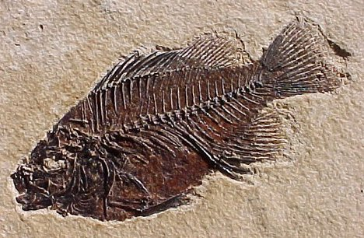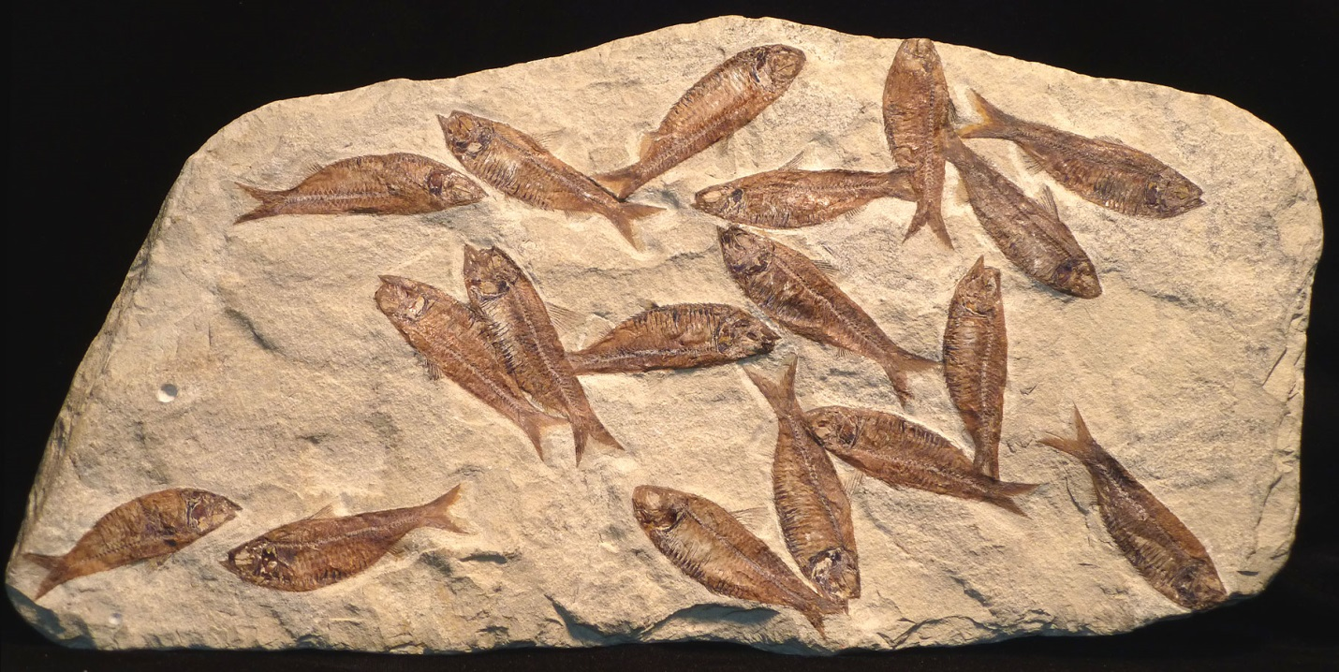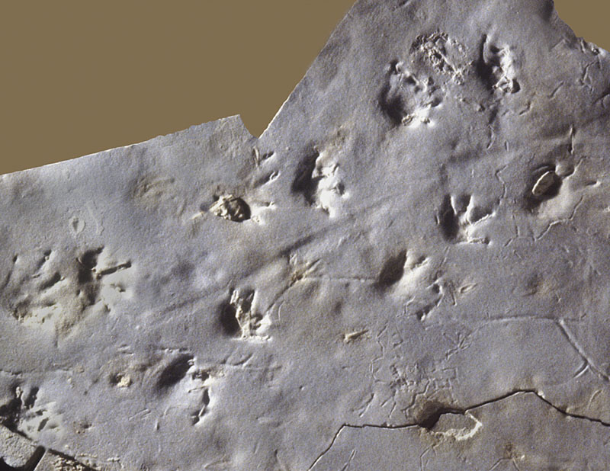
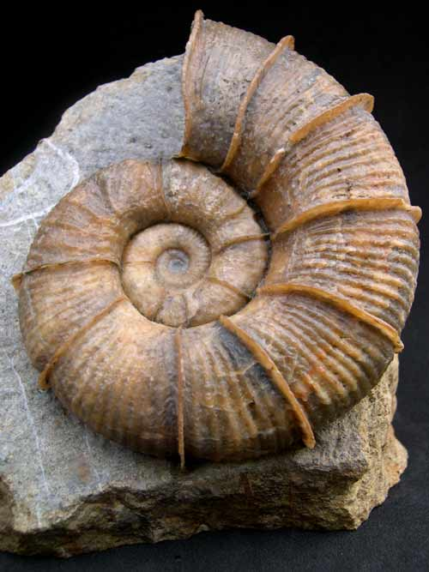
Scientists categorize fossils into three main groups – impression fossils, trace fossils, and replacement fossils.
Amber is also often looked at as a fourth type of fossil. Although a chunk of amber can contain insects that were trapped in resin long ago, technically it is still categorized as a gemstone.
Let’s dig into the three main types of fossils, uncover what they are, and get our hands dirty with an activity!

THE 3 TYPES OF FOSSILS
Fossils are bits of plants or animals that have been preserved from the past.
There are several different kinds of fossils based on how they are formed. Here are the three most common types of fossils:

1. IMPRESSION FOSSILS
These fossils contain prints, or impressions, of plants or animals from long ago. The plant or animal lands in mud, silt, or sand and makes an impression. Over time, it disappears, but the impression remains. The mud, silt, or sand hardens into rock, and an impression fossil remains.

2. TRACE FOSSILS
These types of fossils capture the activities of ancient animals. The animals leave its footprints or scat, which makes an impression in the soft mud, silt, or sand. Just like impression fossils, the soil hardens to form rock, preserving a trace of the animal.

3. REPLACEMENT FOSSILS
These fossils are replicas of things that were once alive, such as trees or sea creatures. These living things are trapped, die, and are covered by mineral-rich water. As they rot, the organic parts are replaced by a hard mineral called silica. The minerals fill in the spaces and create a replacement, or replica, fossil of the living thing.

