5th grade lesson plan oil pastel poppies
Objective: students create a poppy in the style of Georgia O’Keeffe and explain its use as a symbol of remembrance and why.
Students analyze and critique works of art by Georgia O’Keeffe and Claude Monet through Compare and Contrasting
Standards 3: Invent and discover to create: use art materials to convey personal feeling or idea or to create an artwork that represents the idea of others.
Standard 2: Envision and Critique to Reflect
Day 1:
Students come to the meeting area in the front. I will describe the intro activity. I will have students go back to their tables and work as a group for 5 minutes to recall information that they have learned about poppies from the past two years that we have created them. (this will let me know what information they are retaining as well. When the timer goes off the students can share what they recall. Based on that it will let me know if I need to review with them certain information regarding veteran’s day. And I will show a quick video, and have students reflect if we need to. (adjusting based on student needs)(5 minute reflection)
I will then have students compare and contrast two works of art that have poppies as their subject matter. Students will work as a table group again to create statements on sentence strips and then placed in hula hoops that are set up like a venn diagram on the floor to place their strips. And then we will have a quick discussion (5 minutes to do strips) (5 minute discussion) 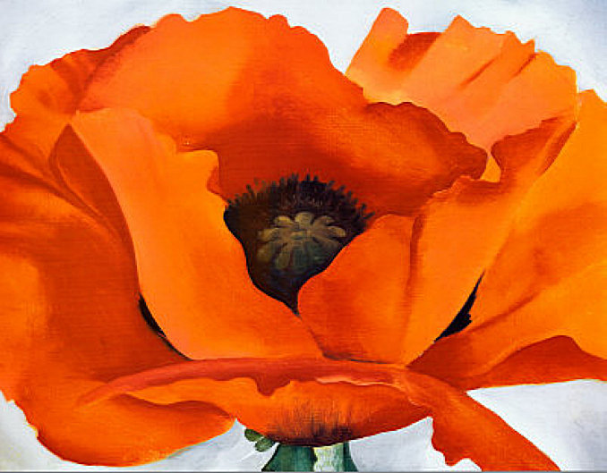 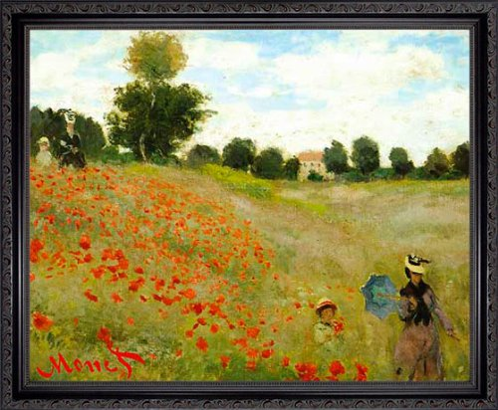
How are these two images of poppies, the single large view by the artist Georgia O’Keeffe and the field of poppies by Claude Monet the same and different?
After the compare and contrast activity have a quick discussion asking why the students think O’Keeffe would have create her image of a poppy emphasizing one and up close, vs showing a field of poppies like Claude Monet?
After taking some of the responses, display the quotes by Georgia O’Keeffe, 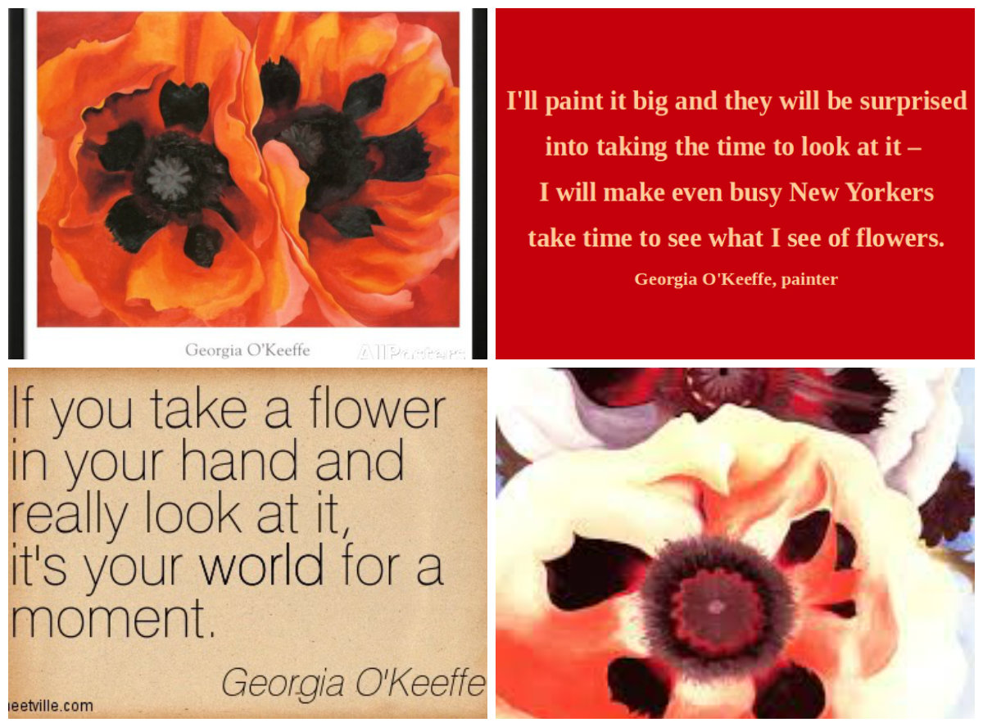Now that we have looked at a couple of quotes from Georgia O’Keeffe how does that help us as viewers understand the artists’ intention or purpose? How can we see this in her artwork? What has she done to reflect this through her paintings?
If there is time I will introduce the project, students will be creating poppy using oil pastels, and creating a composition similar to that of Georgia O’Keeffe. Also if there is time as students to summarize what we did for the day and line up.
Day 2:
Quick reflection on what we did the class time before, students will then go to their seats and I have found a how to video that I can pause and give students time to draw each step, which then allows me time to get around to those that need help and check with them as they are going
Video link: https://www.youtube.com/watch?v=-3uPtNGOJjs
Day three will be finishing drawing and using the oil pastels to blend the color together.
As students are using the oil pastels, discuss what kind of texture we would see on a petal and what they need to do to create more of a smoothed textured to reflect what the actual texture of flower petals are. Also students will be asked to use green as their background vs. the blue advised in the video so that we create contrast by using complementary colors. And go over the vocabulary
Review the vocabulary on Day three as well.
At the end of the project I have created a quiz on Kahoot.com for students to take as a group with the ipads to review the information learned during the lesson. Students go to Kahoot. It and enter the code 874964 to take the quiz.
The questions are also set up to review terms that were given during the pretest for my SLO’s and will be used to determine if groups are retaining the information before being given the test again as a mid assessment.

