First grade math problem penguins
Objective: students combine art and math by creating a math problem based on their collage penguin project.
Students connect art to literacy and social studies as they read and discuss the book Penguin and Pinecone a book about friendship and the national geographic kids book about penguins
Standard 1: Use artwork to express/explain feelings: explain the story that might be found in the artwork)
Standard 4: students relate and connect to transfer
Standard 3: invent and discover to create
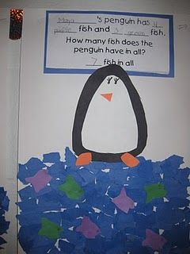
Penguin Math Materials Needed: • Large white construction paper • Black construction paper • Blue construction paper • Various colored construction paper for the fish • Art supplies - glue, scissors, pencils, & crayons • Penguin and fish tracers • Penguin word problems
Teacher directions
Directions: 1. Decide which level of math difficulty you would like for your students to complete. Make a sample project 2. Print and copy the appropriate math sheet. 3. Decide if you would like this to be a whole class project or a center. You can make the activity a center by writing the directions on sentence strips or by printing and placing the direction sheet in the center. 4. Print and create tracers. 5. Set up the center and model or complete the activity as a class. 6. Mount the word problems on blue paper, to complete the project.
Student procedures:
Penguin Addition Directions:
1. Trace and cut out a black body.
2. Trace and cut out a white middle.
3. Glue the penguin together and add details, like feet and a beak.
4. Take a piece of blue construction paper and rip it into small pieces.
5. Glue the small blue pieces to the bottom of the white paper. Use my sample as a guide.
6. Glue the penguin onto the white part of the paper, just above the blue strips of paper.
7. Complete the word problem.
8. Trace and cut out fish to match your word problem.
9. Glue the fish onto the paper. 10. Let your teacher check your word problem before you glue it onto the paper.
Word problem that is on a separate sheet for them to fill out
______________’s penguin has ____ ________ fish and ____ _________ fish. How many fish does the penguin have in all? The penguin has ______ fish in all ______________’s penguin
Class procedures
When introducing this assignment read the story Penguin and Pinecone a friendship story
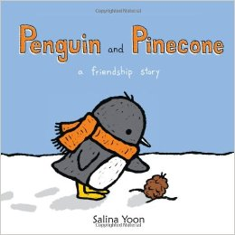 after reading the story students discuss and answer the following questions relating art and literature
How do you think Penguin feels when he thinks the Pinecone is his friend? How has the illustrator helped us see this feeling? How do you think the penguin feels when he has to live far away from the pinecone? How has the illustrator helped us to understand that? What is happening in the illustration that the author has not written about? How does this help us know what is going on?
What kind of story did we just read? Was it Non-fiction or fiction? How do we know that it is fiction?
What do you think Penguins eat? Response should be fish.
Today we are going to create your own penguin getting ready to go fishing, and part of our art project is also going to include math. You will choose two different colors to use as fish when we get to that part and we will add up how many fish in the first color that you have and how many fish in the second color that you have to then add them both up to know how many fish your penguin got to eat.
First lets get back to our tables and start with creating our penguin.
Using the templates that say black body, trace the around the shape on the paper (demo this) on the black construction paper, walk around and assist where needed (sped and ELA supports)
Then cut that shape out. As students are cutting hand out the paper that will be the background for everything to be glued on.
Now we are going to glue the body to your background, make sure that the point of the body is facing up. Allow for students to glue on paper before moving to the next part.
Now we are going to trace our white body part just like we did with the black body part. (demo and assist where needed)
Students cut the shape and then glue down to the black piece, at this point it may be time for clean up, have students clean up scraps, glue and scissor, have students make sure that names are on their paper.
Place papers on the drying rack and line up quiet tables, as they are lining up remind them that the next class period will be adding the water, fish and adding the fish together to create our math word problem to go along with our penguin.

Day two
This will be used for the second day of project We are going to take a look at another story. This story is non-fiction and what does that mean? What is the difference from fiction and non- fiction?
This story is about penguins too. 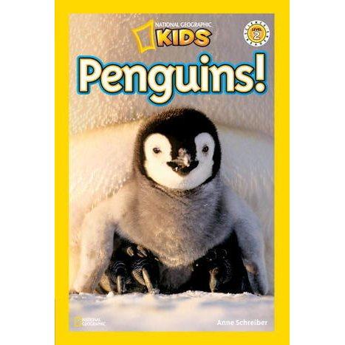
Or use this video to discuss facts about penguins https://www.youtube.com/watch?v=pQMVPsSIyaA
Have students recall facts that they learned from the book or the video.
Then pass out the penguin papers started from the last class period.
Today we are going to add the water with torn pieces of blue paper glued on to our background.
Then you will use the fish template to trace fish and cut them out as well as glue them to your water. Make fish using two different colors.
When done cutting and gluing students then create their word problem using the provided sentences.
They write their name the number of fish in each color followed by the number of fish total.
If there is time then this will be glued to their background and the penguin will have feet, beak and eyes added. If not that will be added the next class period.
Clean up and line up

