kinder snowmen, measuring
Objective: students relate illustrations to art and discuss what they see happening in the images of the story The Biggest Best Snowman Ever and Snowmen at Night 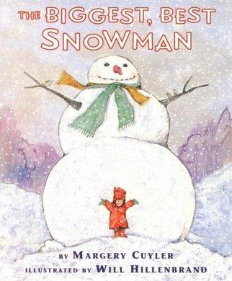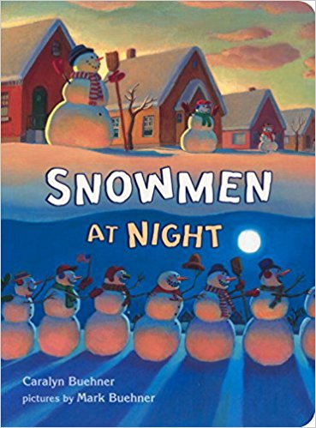
Students create their own snowmen paintings then measure how tall their snowman is using math cubes. Students complete the statement my snowman is ____________________ cubes tall.
Standard 1: Observe and learn to comprehend
Standard 2: envision and critique to reflect
Standard 3: invent and discover to create
Standard 4: relate and connect to transfer
Materials: Math cubes, blue construction paper 12x18, white paint, paintbrushes, paint supplies, white crayon, copies of the math statement, pencil, scissors, glue, collage materials
Discussion questions with the stories
Biggest, Best, Snowman Ever: How does the illustrator use shapes? How has she used line to create the illustrations? What colors do we see? What is a setting? Where is this taking place? What time of year is it? What has the illustrator done to show us this? Is it warm or cold? How can you tell? How has the artist drawn the snowman to help us know that it is the biggest snowman ever?
Snowman at Night: What kind of winter cloths do you wear during the winter? Why do we wear them? What kinds of winter clothes are the snowmen wearing? (list them and draw little pictures to go with them on a chart paper or board for students to reference during collage)
Today we are going to draw out your snowmen and then use the math cubes to measure how tall they are and fill out your math statement My snowman is ______________cubes tall.
Walk through what shape I should use to draw my snowman and have them do that with me
Draw a hat of your choosing on your snowman. Now we are not going to draw a face or other details on our snowmen at the moment so let’s link our math cubes together and start to measure how tall each of your snowmen are.
I will walk around and monitor and help. Take pictures of their measured snowman. Each child will then write the number of cubes it took to get it the same length of the snowman. And then ask each student (by raised hands) whose snowman is larger than 10 cubes, 15 cubes, 20 and so on till the person with the biggest snowman is left.
MY snowman is ________ cubes tall.
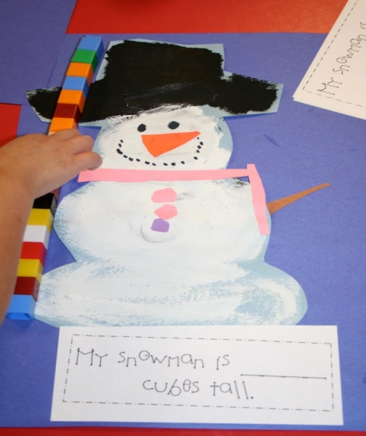
If there is time they can glue their math statement to the bottom of their base paper, and put it on the drying rack and clean up and line up.

MY snowman is ________ cubes tall.
MY snowman is ________ cubes tall.
MY snowman is ________ cubes tall.

MY snowman is ________ cubes tall.

