Ms Andrews
Sumi-e and Haikus

CLO: Students will critique, explain and create sumi e inspired paintings as art relates to poetry and culture using art vocabulary through the use of
a) discussion
b) exit slips
c) readings and group discussions
d) creating sumi e inspired images and haikus

Vocabulary: Sumi e, brush strokes, composition, Haiku, landscape, nature scene

Goal: students create sumi e paintings and write nature haiku’s to go along with them

Objectives:
Students create a nature scene using sumi e techniques
Students create a Haiku to connect to their image
Students participate in creating a group poem called a ranga

Standards 3: Invent and Discover to Create
Standard 1: Observe and Learn to Comprehend

Materials: paper, pencil, watercolors water, paintbrushes, cups, rags, Haiku examples
Resources: Images from internet, and books (see bibliography),
Videos: with brush stroke practice and orchids, Bamboo, plum blossoms
Brush stroke practice: https://www.youtube.com/watch?v=vAoOf1W6abk&t=206s

Plum blossoms: https://www.youtube.com/watch?v=ES9A5Zyjh-Q
Orchid: https://www.youtube.com/watch?v=t7Qv3e4njkw
Bamboo: https://www.youtube.com/watch?v=v527vJObd64

Vocabulary
Haiku: a 3 line poem with a syllable pattern of 5-7-5. Uses natural themes, expressing sensory experiences and emotion. But not specifying the actual emotion
Ranga: linked verse poems written collaboratively. Structured in alternating stanzas or links of 5-7-5 and then 7-7 syllables *(Using Ranga in the Classroom handout)
Procedure:
Day 1
Students are introduced to Haikus and where they came from, how to create them.
When we discuss and analyze the visualization of the examples students will then create their own Haiku
Students share the haikus with the group
Day 2
Students review how to create a Haiku.
Students are then introduced to Ranga poems and the processes in creating a poem as a group.
Students are seated in a circle
Students create their own Haiku that is to be passed to the person to their right to create the next stanza using the 7,7 syllables,
Pass again to the right with the 5,7,5 syllables
Continue the pattern provided explaining the rules on certain lines for students to include visuals of the moon and seasons and love (* Using Renga in the Classroom handout)
Day 3, Day 4, Day 5
Continue the group writing processes for the next three days creating as many stanzas as the students can think of.

When the group poem is done return to the original student to read to the group. Allowing each student a chance to read the outcome of the group effort.
Reflect on process and results

Second week
Day 1
students will write three individual Haikus then the page will be passed to the other students in the group.
Each student will place a check next to the poem they think is the best out of the three.
The votes will be tallied and that winning poem will be the one the student creates a sumi e image for.
Students will be introduced to sumi e art and the process of creating the ink paintings
A technique of using charcoal then using a wet brush to create brush strokes on the paper will be demonstrated to students.
Images of examples will be displayed to students to discuss and practice to choose a image to create for their poems
Day 2:
Students practice different elements with the brush and charcoal to prepare for a final piece show brush stroke video pausing to allow students the opportunity to practice and demonstrate a second time for clarification. While students are practicing I am walking around and providing supports.
Clean up
Day 3
Create an image to use as a background for their Haiku
Day 4:
Type up their Haiku
Trace onto the sumi e paper
Answer reflection questions

What is a Haiku?
What are your reactions to having created a group poem?
What was the most difficult part of having to work as a group and why?
What was the most enjoyable part of having to work on a group poem; Why?

Resources: Handouts for Students

Four Haiku by Matsuo Basho
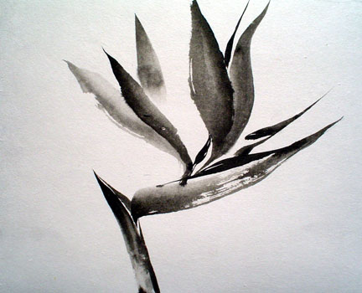
Spring:
A hill without a name
Veiled in morning mist.
The beginning of autumn:
Sea and emerald paddy
Both the same green.
The winds of autumn
Blow: yet still green
The chestnut husks.
A flash of lightning:
Into the gloom
Goes the heron's cry.

http://famouspoetsandpoems.com/poets/matsuo_basho/poems/401.html
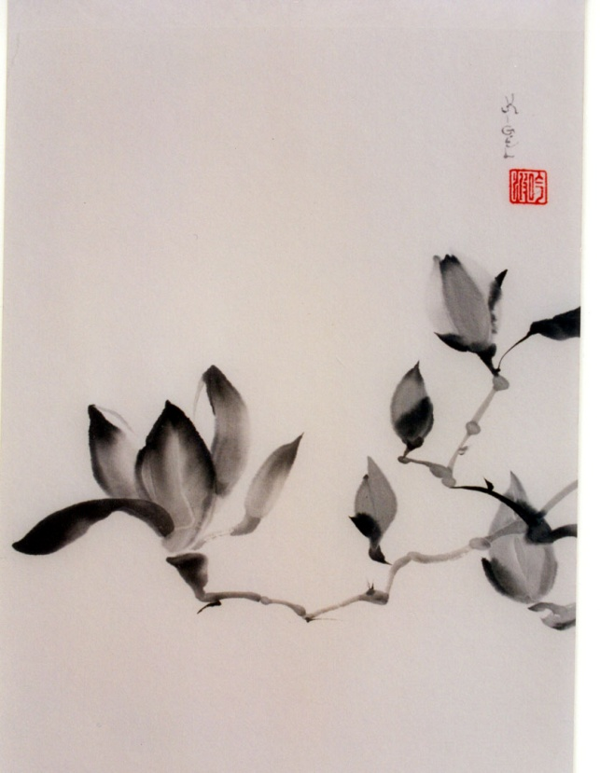
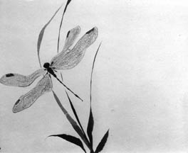

How to Write a "Haiku" Poem

by Bruce Lansky
Haiku poetry is a very short, centuries-old form of Japanese poetry that is an intriguing change of pace from the kind of rhythmic, rhyming poetry you're used to reading. Haiku is like a photo that captures the essence of what's happening, often connecting two seemingly unrelated things.
Snow melts.
Suddenly, the village
is full of children.
(Written by Issa. Translated by Bruce Lansky. Copyright 1999 by Bruce Lansky, reprinted with his permission)

Frog sunning on lily pad
as dragonfly darts by.
Thrapp!
(by Bruce Lansky. Copyright 1999 by Bruce Lansky, reprinted with his permission)
Although traditional haiku are often about nature or the changing seasons, they nonetheless manage to convey emotion. With just a few words, they call attention to an observation and in effect say, "Look at this" or, "Think about this." If they're well written, we can't help but do just that. The haiku calls the reader's attention to the story behind the observation.
Traditional Japanese haiku had a total of seventeen syllables divided into three clumps (or lines):
five syllables
seven syllables
five syllables
I think the best stimuli for writing haiku are nature hikes, nature photography, or art. Try this: Write down what you see when you go outside for recess or when you go for a walk in the woods over the weekend. Write down your observations on paper (or better yet, record them with a camera). Depending on the season, you might get observations of nature like the following:
leaves blowing in the wind
snow piling up on unused doors
ducks swimming in a pond during a rainstorm
the first buds on tree branches in your backyard
the first daffodil poking it's head through the dirt
hungry bees buzzing around a flower garden
Next, try to find two images that create a striking impression when connected and write them down. You might get something like this:
After it started to rain, fishermen steered their boats toward the shore. Then, I saw a family of ducks waddle over to the lake and swim across.
OK, now you have to pare the sentence down so it still describes the scene while inviting the reader to marvel at nature. How's this?
Sudden spring storm-
a family of ducks paddles
around the deserted lake.
(Copyright 1999 by Bruce Lansky, reprinted with his permission)
I think that haiku is a lot closer to photography or painting than it is to the kind of humorous poetry I often write. It teaches the power of observation and the importance of editing. You know you've done a good job of editing when the version with the fewest words makes the strongest impression.

http://www.gigglepoetry.com/poetryclass/Haiku.html

Japanese Poetry Forms
Numerous distinct poetry forms have been employed in the history of Japanese literature. Many of the forms have
fallen out of fashion over time, but a handful have survived to the present. This handout seeks to introduce the reader
to a few of these forms, especially those forms which continue to be popular today.
Tanka: Though this poetry form dates from the Heian period (8th to 12th c. CE), the name itself, meaning “short song,” is
an invention of nineteenth century poet Masaoka Shiki. Tanka were historically one of the forms of waka, or “Japanese
poetry,” a genre distinguished by the fact that it was written in Japanese, rather than in Chinese. There were several
historical forms of waka, but only the tanka survives in modern usage. Tanka consist of five lines of 5‐7‐5‐7‐7 syllables
respectively. Tanka traditionally use natural images, often using them to express feelings of love. Tanka is the closest
thing there is in Japanese to lyric poetry, in that it is highly personal and emotional. Tanka were collected in imperial
sponsored anthologies from at least the eighth century onward. Accordingly, there is a wealth of historic tanka
available, much of which has been translated into English. Tanka, during the Heian period (794‐1185 CE), became a
vehicle for demonstrating a highly refined aesthetic sense by members of the upper reaches of the imperial court. Since
a refined aesthetic sense came to be equated with someone’s attractiveness, tanka were often used in the Heian period
to initiate affairs. Over the course of an affair, lovers would also use tanka to express their emotions, often writing
poems about the missing loved one, or the longing the poet was feeling for someone. Heian period tanka are some of
the most exquisite poetry ever written. One of the great masters of the tanka is Saigyo, a wandering monk, who
traveled extensively across Japan at the end of the Heian period
Renga: Renga are collaborative poems of various lengths. Renga were originally a diversion from the serious occupation
of writing waka by Heian period court poets. Over time, renga became a serious art form in its own right. The two great
historic masters of the renga are Sogi (1421‐1502 CE) and Matsuo Bashō (1644‐1694). Under Basho, renga developed
into poetry concerned with direct sensory experience, nature and seasonal references.
Haiku: Haiku is probably the most popular and best known form of Japanese poetry. Haiku are written worldwide by
young and old alike. Haiku grew out of the first link of a renga, the hokku, which was written to stand alone, and so is a
3 line poem with a syllable pattern of 5‐7‐5. Haiku use natural themes, expressed as direct sensory experiences, in order
to express an emotion. Haiku do not actually specify the emotion. The reader should be able to grasp the emotion from
the reading. Haiku must have two elements which are called kigo or kidai and kireiji in Japanese. Kigo is the naming of a
season, while kidai are suggestions of the season. For example, a haiku may use the word “autumn” (or “fall”), which
would be kigo; or may use the words “tall grass” to suggest summer or “frozen pond” to indicate winter, which would be
kidai. There are books in Japanese with lists of kigo and kidai, meant to give inspiration to haiku poets. Kireiji is a
cutting word, meant to offset one part of the poem from another. In English, kireiji are usually done with punctuation
marks like dashes and exclamation marks, but in Japanese, words generally serve this purpose. Kireiji are meant to
create an internal comparison in the poem. A good example of both kidai and kireiji in use is Bashō’s famous haiku,
presented in Japanese and English:
Japanese, transliterated English
furike ya
kawazu tobikomu
mizu no oto
an ancient pond—
a frog jumps in
the sound of water
In the original version, the word “ya” is the kireiji, which offsets the pond from the frog and the sound of the splash. In
the English version, the dash is the kireiji. In both cases, the pond and its implied stillness is compared to the sound of
the frog jumping in. The kidai is the frog, suggesting spring to the Japanese. This haiku is also an excellent example of
using natural imagery conveyed as direct sensory experience to elicit an emotion on the part of the reader. Basho is the
original haiku master. Other masters of the form throughout Japanese history are Buson (1716‐1784), Issa (1762‐1826)
and Masaoka Shiki (1867‐1902). Shiki, in fact, is responsible for the term “haiku” itself. Prior to him, the poems were
called hokku. In the west, several great poets have written haiku, among them Ezra Pound, Octavio Paz and Gary
Snyder.
Haibun: Haibun is autobiographical narrative prose that incorporates haiku. Usually, the prose portions of a haibun
incorporate poetic rhythms and imagery, and so become poetic themselves, at least in part. Haibun is often very
personal, like a diary or journal. Haibun developed in the seventeenth century, and lie within the tradition of poetic
diaries that dates back to the early Heian period. The most famous haibun is Matsuo Bashō’s Oku no Hosomichi or
Backroads to Far Towns. There are several other great haibun, including Issa’s My Spring, and Masaoki Shiki’s Verse
Record of My Peonies.
Haiga: Haiga are paintings done in the spirit of haiku, accompanied by a haiku. The paintings, however, do not illustrate
the haiku, but rather are responses to haiku, often in juxtaposition to the poem. Haiga are generally done in
monochromatic ink, but not always, and are accompanied by the haiku done in calligraphy. Haiga grew out of a long
Chinese tradition of monochromatic ink painting as practiced by the scholar‐gentry. Often these paintings were
accompanied by poems. Haiga developed during the seventeenth century. While Bashō, the master of haiku, often did
simple haiga, Buson, the great haiku poet of the eighteenth century, elevated it to high art. Some of Buson’s most
famous works are his haiga painted in response to Bashō’s Oku no Hosomichi. Haiga is alive and well in modern Japan
and it continues to be a popular hobby.
Senryu: These poems have the same rhythmic form as haiku, but differ in subject matter, in that they don’t usually use
natural imagery. Senryu are usually humorous and often ironic commentaries on the state of humanity. The name
comes from Karai Senryu (1718‐1790) who published an anthology of these types of poems, thus popularizing them.
Senryu developed in the eighteenth century at the same time that Japan was becoming more urban and the merchant
class aesthetic was becoming dominant. Senryu are an urban poetry, reflecting the concerns of city‐dwellers. Senryu
are often much earthier than haiku, and occasionally, they are even vulgar. Senryu can be good in the classroom, since
the wider range of subject matter may be more accessible to students than haiku.

Using Renga in the Classroom1
Renga are linked verse poems written collaboratively. Renga are structured in alternating stanzas or
links of 5‐7‐5 and then 7‐7 syllables. Authorship of each link alternates, which is what makes it
collaborative. The first link of a renga, called the hokku, should be able to stand on its own as a poem,
but the subsequent verses need not. Each link relates to the previous link, but the relationship should
be subtle or surprising. The relationship between the two links might be a pun or something indicating
mood or something else seemingly tangential. Connections between links may allude to other poems or
may express the mood of the preceding link using different images. In a sense, a link is launched by the
previous link, and may head off into new territory. Any given link must only relate to its adjacent links,
and no others, with the exception of the final link, which relate back to the first. For example, the
second link should relate in some way to the first and the third should relate to the second, but there
should no connection between the first and third. It is the twists and turns of the poem that make the
renga interesting.
Renga generally deal with the same sorts of themes that haiku deal with, such as nature, the seasons
and direct sensory experience. Haiku, in fact, developed from the hokku of renga. Renga comes from
the tradition of courtly poetry, developing as a diversion for those poets. Over time, it became an art
form in its own right. Renga should be spontaneous, humorous, lively and fun. Renga is a fabulous way
to do collaborative poetry in the classroom. You can write in large groups, small groups, or whatever
sized groups you may have. If you have a particularly large group of students, you may want to split
them into smaller groups, but do not put them in groups that are too small
Renga may vary in length with some historic renga going for 1000 links long. The most traditional form
is the 36 link kasen renga. This form was popularized by Bashō and his followers in the seventeenth
century. The kasen renga is manageable in a classroom setting, but may require more than one class
period to complete.
In order to execute kasen renga in the classroom, I suggest the following:
1. Have students write the first link at home in order to save time. The first link is essentially a haiku,
and so must be able to stand alone. Tell students to bring this first link to class the day of the renga.
2. Arrange your class so that students are sitting in a circle and have a writing surface in front of them.
3. Have each student take three sheets of lined paper and staple them together. Students will also
want some scratch paper to work their links out on before they commit them to the renga.
4. On the front of the first sheet, write the numbers 1‐6 down the left margin, spacing them so that
they are roughly proportional.
5. On the back of the first do the same with the numbers 7‐12.
6. On the front of the second, do the same with the numbers 13‐18, and so on up to 36 on the back of
the last page.
7. Then, have each student write their first link next to #1 on page 1 of their stapled pages.
1 Dr. Laurel Rodd, Director of the Center for Asian Studies at the University of Colorado at Boulder, assisted me
with some of the procedures and rules for the kasen renga.
8. When all have finished, have them pass their sheet to the person sitting to their right. Instruct them
to write a link consisting of two lines of seven syllables each that relates in some way to the first link.
Let them know that the link does not need to be a complete poem. It can be an incomplete,
unfinished verse, a mere suggestion of what they are trying to get across.
9. When they finish the second link, have them pass the pages to the right again. They should then
write a three line link in the form of 5‐7‐5, like the first link, that relates to the previous link in some
way.
10. Do this 33 more times, alternating 5‐7‐5 and 7‐7. The odd numbered links are 5‐7‐5 and the even
are 7‐7.
11. When it comes time to write the final verse, tell students that it should link to the previous verse
and also the first verse. When that is done, you will have as many renga as there are students in
class.
Be sure to emphasize to the students that they should have fun with their poems. They can make jokes,
puns, etc. They may also write some touchingly beautiful verses. It’s up to them.
There are many complicated rules for traditional kasen renga, many of which aren’t appropriate for the
classroom. Those rules that seem to make the most sense for writing renga in the classroom are as
follows, but since this is a game, feel free to ignore all of them except rule 7:
1. Reference the moon in links 5, 14, and 29, or close to link 29.
2. Reference flowers in links 17 and 34.
3. There should be a love verse in each group of links, 1‐6, 7‐18, 19‐31 and 31‐36.
4. Don't continue winter or summer themed verses for more than two links.
5. Don't continue spring or fall more than three.
6. Try to get the whole variety of human experience into the overall kasen.
7. Have fun.
Kasen renga is not the only option. Other possible lengths for renga are the hakuin of one‐hundred
links, the nijuin of twenty links, and the half‐kasen, or han‐kasen, of 18 links. Of course, for the
classroom you can write renga of whatever number of links seems to work for you and your students.
Another good classroom option is the tan‐renga, in which two people collaborate on what is essentially
a tanka. One student will write the opening link, consisting of three lines of 5‐7‐5 syllables respectively.
Then another student will write a link of two lines of 7‐7 syllables to complete the poem. The result is a
tanka, but the subject matter can be more haiku‐like. Several rounds of tan‐renga are manageable in
one class period.

